### FINAL PROJECT REPORT

**ON**

### “E – LEARNING’’

Submitted in partial fulfillment of the requirements for the award of degree of

### BACHELOR OF ENGINEERING

### IN

### COMPUTER SCIENCE & ENGINEERING

### Submitted to: Er Prabhneet Singh

### Submitted By:

### Megha Joshi (20BCS7950)

### Shubham Gupta (20BCS7538)

### Saumya Saloni (20BCS7542)

### Pragya Shrivastava (20BCS7528)

**DEPARTMENT OF COMPUTER SCIENCE & ENGINEERING**

**Chandigarh University,**

**Gharuan**

### Table Of Content

|  |
| --- |
| Topic Page No. Certificate 3  Student’s Declaration 4  Acknowledgement 5  Abstract 6  **CHAPTER 1 INTRODUCTION 7-10**  **1.1** Theoretical Explanation 7  **1.2** Software and Hardware tools required for project 8-10  **CHAPTER 2 MATERIAL AND METHODOLOGY 11-13**  2.1 Proposed Work 11-12  2.2 Team Work 13  **CHAPTER 3 RESULTS AND SNAPSHOTS 14-43**  3.1 Result 14  3.2 Snapshots 15-43  **CHAPTER 4 CONCLUSION AND FUTURE SCOPE 44-45**  4.1 Future Scope 44  4.2 Conclusions45  **REFERENCES 46** |

### 

### 

### CERTIFICATE

This is to certify that the work embodied in this Project Report entitled **“E- LEARNING”**, being submitted by “20BCS7950, 20BCS7528, 20BCS7542, 20BCS7538”, for partial fulfillment of the requirement for **“Institutional Training”** during the session **JUNE- JULY 2021** is a record of bona fide piece of work, carried out by student under my my supervision and guidance in the **“Department of Computer Science & Engineering”, Chandigarh University.**

**DECLARATION**

We, student of Bachelor of Engineering in Computer Science & Engineering, 2nd Semester, session: JAN-JUNE 2021, Chandigarh University, hereby declare that the work presented in this Project Report entitled “E-LEARNING” is the outcome of our own work, is bona fide and correct to the best of our knowledge and this work has been carried out taking care of Engineering Ethics. The work presented does not infringe any patent work and has not been submitted to any other university or anywhere else for the award of any degree or any professional diploma.

### Students details and Signature

### MEGHA JOSHI (20BCS7950)

### SHUBHAM GUPTA (20BCS7538)

### SAUMYA SALONI (20BCS7542)

### PRAGYA SHRIVASTAVA (20BCS7528)

**APPROVED & GUIDED BY:**

### To our Project In charge “ER PRABHNEET SINGH”.

**ACKNOWLEDGEMENT**

We would like to express our deep and sincere gratitude to our Project In charge **ER PRABHNEET SINGH** for giving us the opportunity to do the project and providing valuable guidance throughout this research. Their dynamism, vision and exquisite efforts have deeply inspired us. They taught us the methodology to carry out the research and to present the research work as clearly as possible. It was a great privilege for us to study and work under their guidance.

We owe the completion of our project to our project Mentor for his continuous support and guidance.

**ABSTRACT**

Our Aim is to design and create a working website for **E-LEARNING**. This enhances the quality of learning and teaching. This project meets the learning style or needs of students. This website has a very user-friendly interface. Thus, the users will feel very easy to work on it. By using this system admin can manage contacts, uploading study materials, Notes and Videos, the information can also be edited or deleted by the Administrator. Web Traffic report can be retrieved by the admin, when it is required. Thus, it is easy for the user to access the study material. It also provides few games to refresh user’s mind.

**CHAPTER 1**

### INTRODUCTION

This project is designed so as to be used by the students and the teachers. It is a system through which educators and education seekers can access study material like notes and videos. The advancement of technologies has greatly changed the way of teaching and studying which is found to be beneficial.

E-Learning website is being developed for educators and education seekers so that they can get access to the study material like notes and videos. This application provides study materials like notes and videos for the subject that student or the teacher requires. It also has few games for the student to refresh his/her mind.

It has a user-friendly interface. The user can get subjects like BEEE, PHYSICS, MATHS etc.

**Benefits of E-Learning**

* + E-Learning saves time and money
  + E-Learning leads to better retention
  + E-Learning is the way of future
  + E-Learning provides access to training

E-Learning has emerged with some new goodies compared to physical learning with books where every study material is limited to a certain extend. Even though the physical learning has not been totally eradicated. Nowadays, during the pandemic there was a great loss in the education of a student. Everything got converted from physical to e-learning, which has been beneficial for both the students and the teachers.

The website does not only provide with the study material but also it keeps in mind the refreshment of the student’s brain.

**1.2 Languages,Software and Hardware tools required for Project-**

Languages:

* **HTML**

HTML stands for Hyper Text Markup Language**.** Itis the standard markup language for creating Web pages**.** It describes the structure of a Webpage**.** It consists of a series of elements. HTML elements tell the browser how to display the content**.**HTML elements label pieces of content such as "this is a heading", "this is a paragraph", "this is a link", etc.

**Hypertext Markup Language** (**HTML**) is the standard [markup language](https://en.wikipedia.org/wiki/Markup_language) for documents designed to be displayed in a [web browser](https://en.wikipedia.org/wiki/Web_browser). It can be assisted by technologies such as [Cascading](https://en.wikipedia.org/wiki/Cascading_Style_Sheets) [Style Sheets](https://en.wikipedia.org/wiki/Cascading_Style_Sheets) (CSS) and [scripting languages](https://en.wikipedia.org/wiki/Scripting_language) such as [JavaScript](https://en.wikipedia.org/wiki/JavaScript).

* **CSS**

CSS stands for Cascading Style Sheets. CSS describes how HTML elements are to be displayed on screen, paper, or in other media. CSS saves a lot of work. It can control the layout of multiple web pages all at once. External stylesheets are stored in CSS files

* **JAVASCRIPT**

**JavaScript** often abbreviated as **JS**, is a [programming language](https://en.wikipedia.org/wiki/Programming_language) that conforms to the [ECMAScript](https://en.wikipedia.org/wiki/ECMAScript) specification.[[7]](https://en.wikipedia.org/wiki/JavaScript#cite_note-tc39-7) JavaScript is [high-level,](https://en.wikipedia.org/wiki/High-level_programming_language) often [just-in-time compiled](https://en.wikipedia.org/wiki/Just-in-time_compilation), and [multi-](https://en.wikipedia.org/wiki/Programming_paradigm) [paradigm.](https://en.wikipedia.org/wiki/Programming_paradigm) It has [curly-bracket syntax](https://en.wikipedia.org/wiki/List_of_programming_languages_by_type#Curly-bracket_languages), [dynamic typing,](https://en.wikipedia.org/wiki/Dynamic_typing) [prototype-based](https://en.wikipedia.org/wiki/Prototype-based_programming) [object-orientation](https://en.wikipedia.org/wiki/Object-oriented_programming), and [first-class functions.](https://en.wikipedia.org/wiki/First-class_function)

Alongside [HTML](https://en.wikipedia.org/wiki/HTML) and [CSS](https://en.wikipedia.org/wiki/CSS), JavaScript is one of the core technologies of the [World Wide](https://en.wikipedia.org/wiki/World_Wide_Web) [Web](https://en.wikipedia.org/wiki/World_Wide_Web)[.](https://en.wikipedia.org/wiki/JavaScript#cite_note-8) JavaScript enables interactive [web pages](https://en.wikipedia.org/wiki/Web_page) and is an essential part of [web applications](https://en.wikipedia.org/wiki/Web_application). The vast majority of [websites](https://en.wikipedia.org/wiki/Website) use it for [client-side](https://en.wikipedia.org/wiki/Client-side) page behavior,and all major [web](https://en.wikipedia.org/wiki/Web_browser) [browsers](https://en.wikipedia.org/wiki/Web_browser) have a dedicated [JavaScript engine](https://en.wikipedia.org/wiki/JavaScript_engine) to execute it.

* PHP

**PHP** is a [general-purpose](https://en.wikipedia.org/wiki/General-purpose_programming_language) [scripting language](https://en.wikipedia.org/wiki/Scripting_language) that is especially suited to [web development](https://en.wikipedia.org/wiki/Web_development). It was originally created by Danish-Canadian [programmer](https://en.wikipedia.org/wiki/Programmer) [Rasmus Lerdorf](https://en.wikipedia.org/wiki/Rasmus_Lerdorf) in 1994; the PHP [reference](https://en.wikipedia.org/wiki/Reference_implementation) [implementation](https://en.wikipedia.org/wiki/Reference_implementation) is now produced by The PHP Group. PHP originally stood for *Personal Home Page*,but it now stands for the [recursive initialism](https://en.wikipedia.org/wiki/Recursive_initialism) *PHP: Hypertext Preprocessor*

* **MY SQL**

SQL is a standard language for accessing and manipulating databases. SQL stands for Structured Query Language. SQL lets you access and manipulate databases. SQL became a standard of the American National Standards Institute (ANSI) in 1986, and of the International Organization for Standardization (ISO) in 1987

SQL can execute queries against a database, retrieve data, insert records in a database, update records, delete records, create new databases, create new tables in a database, create stored procedures in a database, create views in a database, set permissions on tables, procedures, and views.

**SOFTWARE:**

* XAMPP

XAMPP is a most popular PHP Development Environment.

* **VS CODE**

**Visual** Studio **Code** is a **code** editor redefined and optimized for building and debugging modern web and cloud applications.

**Hardware:**

* Processor (CPU) with 2 gigahertz (GHz) frequency or above
* A minimum of 2 GB of RAM
* Monitor Resolution 1024 X 768 or higher
* A minimum of 20 GB of available space on the hard disk. Internet Connection Broadband (high-speed) Internet connection with a speed of 4 Mbps.
* Keyboard and a Microsoft Mouse or some other compatible pointing device.

CHAPTER 2

**MATERIAL AND METHODOLOGY**

Several materials are used to build this project. Certain software interfaces are used like window 8/10, 4gb ram/ 255gb hdd. Technologies are also used like JAVASCRIPT, MY SQL, PHP, for full stack development tools.

* First of all, you have to search and open the website.
* You will be directed to the home age of the website.
* Then you will find some icons on the top such as HOME, ABOUT US, TOP CAREERS, APPLICATION FORMS etc.
* Users can click on the icon that he/she requires.
* Users will be directed to the page he/she has selected.
* Users can also contact us for their queries.

### MODEL APPROACH

**INTERFACE REQUIREMENTS**

* SOFTWARE INTERFACE
* Windows 8/10.
* 4 gb ram / 256gb hdd
* MySQL
* Html
* JavaScript & PHP

Several materials are used to build this project. Certain software interfaces are used like window 8/10, 4gb ram/ 255gb hdd, MySQL. Technologies are also used like JavaScript for development of the project. MySQL is used for free open-source database to store the data.

**TEAM WORK –**

**Shubham Gupta** – Backend, Styling and PPT preparation

**Megha Joshi**- JavaScript and project report

**Saumya Saloni-** Front end, JavaScript and PPT preparation

**Pragya Shrivastava-** Minimal work

**CHAPTER 3**

**RESULT AND SNAPSHOTS**

**3.1 RESULT**

Therefore, after implementing all the mentioned libraries as well as software tools, we finally full-fledge website where users can fill forms, see careers and get study material.

**CODE AND RESULT-**

**Home-**

<!DOCTYPE html>

<html lang="en">

<head>

    <meta charset="UTF-8">

    <meta name="viewport" content="width=device-width, initial-scale=1.0">

    <title>home</title>

*<!-- custom css file link  -->*

    <link rel="stylesheet" href="css/style.css">

</head>

<body>

<div class="container">

<header>

    <a href="#" class="logo">E-<span>Learner</span></a>

    <div id="menu" class="fas fa-bars"></div>

    <nav class="navbar">

        <a href="home.html">Home</a>

        <a href="about.html">About us</a>

        <a href="https://www.sarkariresult.com/">Application forms</a>

        <a href="https://www.upgrad.com/blog/top-career-options-after-engineering/">Top Careers</a>

        <a href="contact.html">Contact</a>

    </nav>

</header>

*<!-- home section  -->*

<section class="home">

    <div class="content">

        <h3>Learning together even when we're apart</h3>

        <p>Saves us time and means we can learn on the go; so it eliminates the boundaries of the classroom. It enables us to easily learn about the world and gain better skills.</p>

        <a href="getstarted.html" class="btn">get started</a>

    </div>

    <div class="image">

        <img src="images/2.png" alt="">

    </div>

</section>

*<!-- footer section  -->*

<section class="footer">

    <div class="box-container">

        <div class="box">

            <h3>quick links</h3>

            <a href="home.html">home</a>

            <a href="about.html">About Website</a>

            <a href="https://www.sarkariresult.com/">Application form</a>

            <a href="https://www.upgrad.com/blog/top-career-options-after-engineering/">Top Careers</a>

            <a href="contact.html">contact</a>

        </div>

        <div class="box">

            <h3>follow us</h3>

            <a href="https://www.instagram.com/shubhamgupta_9_4/">instagram</a>

            <a href="https://www.linkedin.com/in/saumya-saloni-32418b212">linkedin</a>

        </div>

        <div class="box">

            <h3>contact us</h3>

           <p> <i class="fas fa-phone"></i>Contact No: 8848511980,9140905236  </p>

           <p> <i class="fas fa-envelope"></i><a href="https://www.gmail.com">E-mail: elearner86483@gmail.com</a></p>

           <p> <i class="fas fa-map-marker-alt"></i><a href="https://www.google.com/maps/place/Chandigarh+University/@30.7691099,76.573665,17z/data=!3m1!4b1!4m5!3m4!1s0x390ffb140bd63e07:0x68591e334d17a988!8m2!3d30.7691099!4d76.5758537">Address:Chandigarh University, Mohali ,Punjab INDIA 140301.<br>

   Postal-code:323456.</a>  </p>

        </div>

    </div>

</section>

</div>

</body>

</html>

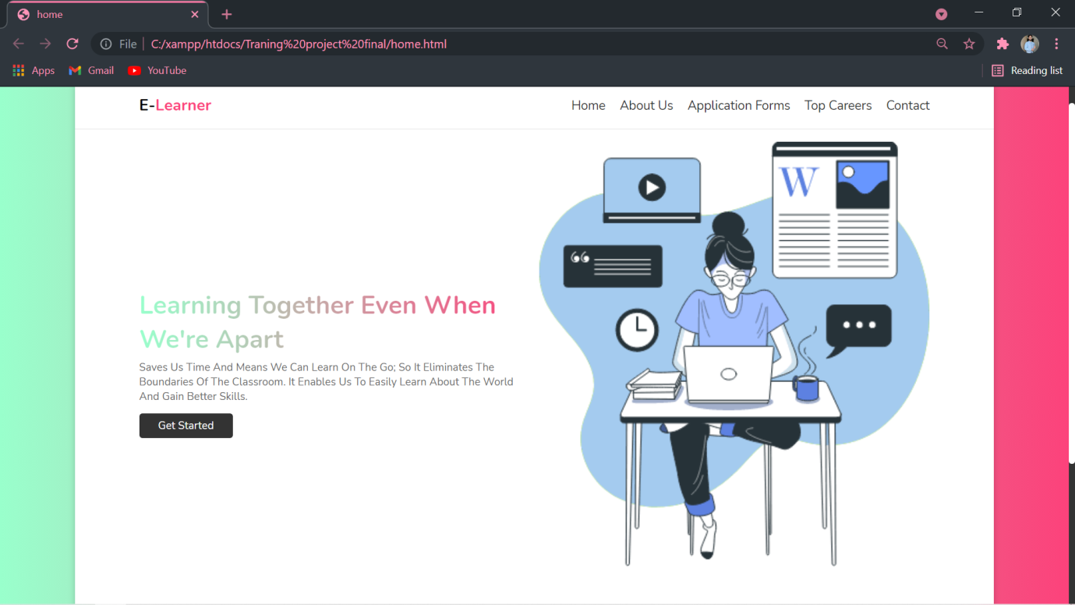

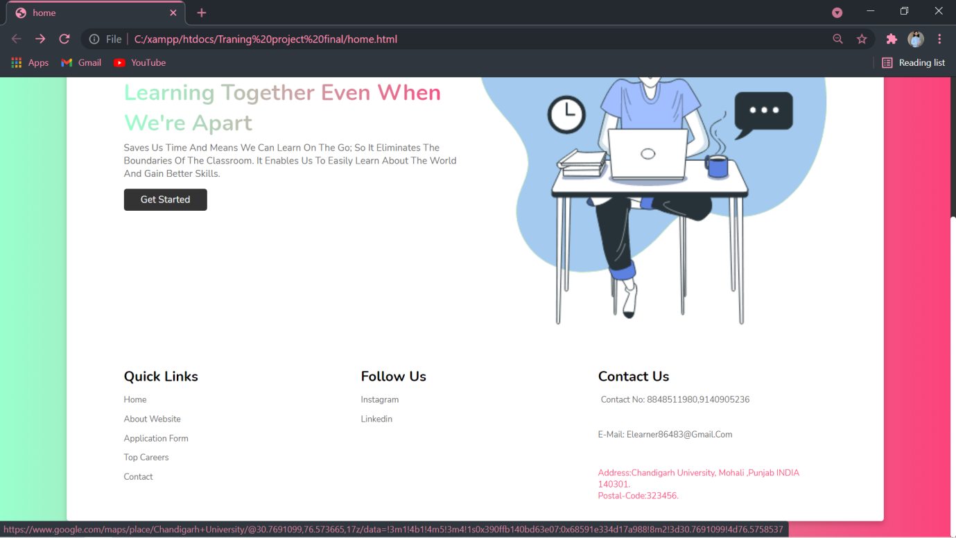

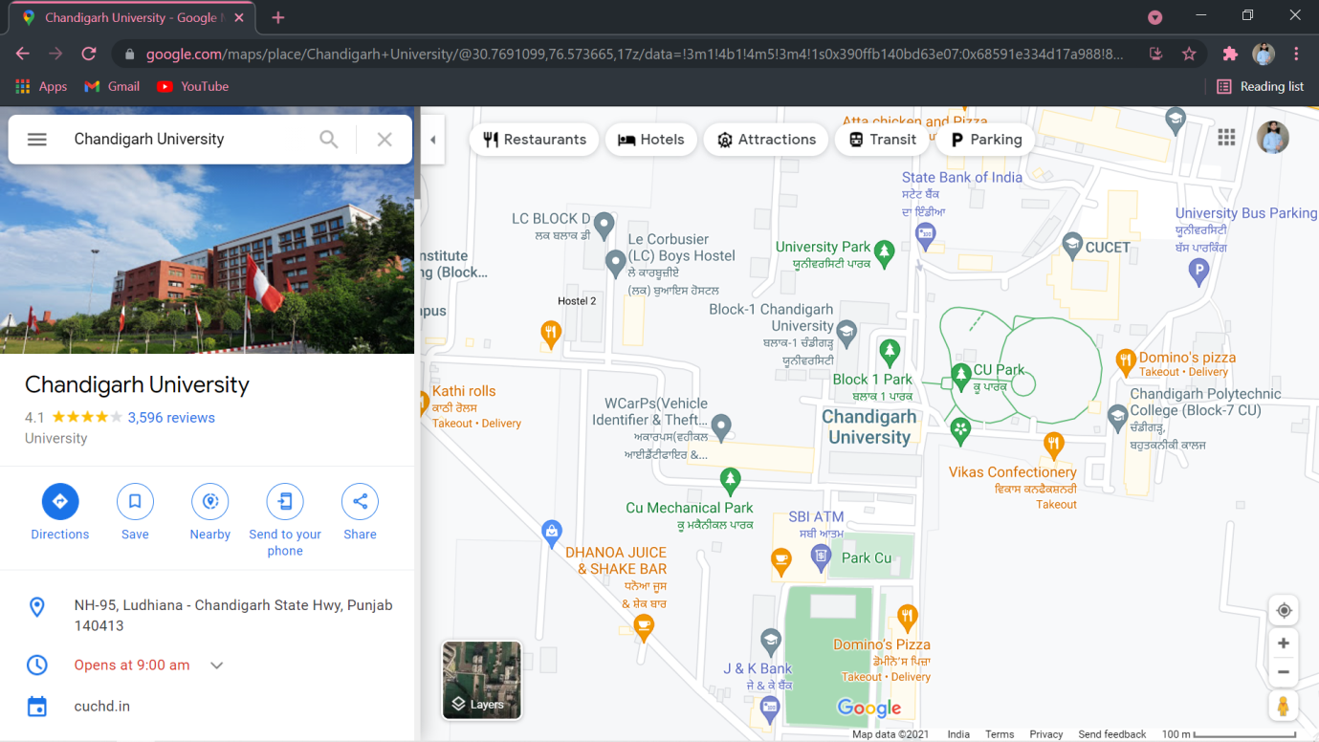

**ABOUT-**

<!Doctype html>

<html>

<head>

<title>about</title>

<style>

   h1{

      font-size: 40px;

   }

   p{

      margin-left: 100px;

      margin-right: 180px;

      font-size: 18px;

   }

   body{

      background-image:url("https://bronzebaxxtanning.com/wp-content/uploads/page-background-blue.jpg");

                background-size:100%;

   }

</style>

</head>

<body>

<center><marquee width="50%" direction="right" height="50%" style="color: rgb(8, 8, 3); ">

   <h1>About US.</h1>

</marquee></h1></center>

<p>This Website is a complete stop for those students who wants to study regularly as well as require several resources for their academic glories.It provides you a variety of video lectures as well as notes which gives you best and time-Saving experience for good results. This website was made on 23/JUNE/2021.<br>

<br>

<center><h3>The Creators of this website are:</h3>

<h3>Shubham Gupta</h3>

<h3>Megha Joshi </h3>

<h3>Saumya Saloni</h3>

<h3>Pragya Shrivastava</h3>

</p></center>

</body>

</html>

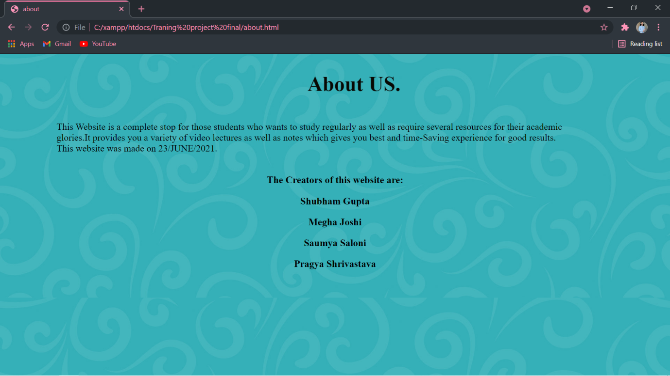

**Application form-**

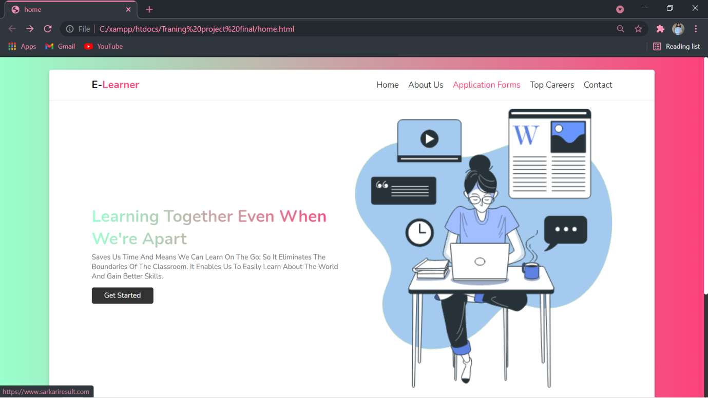

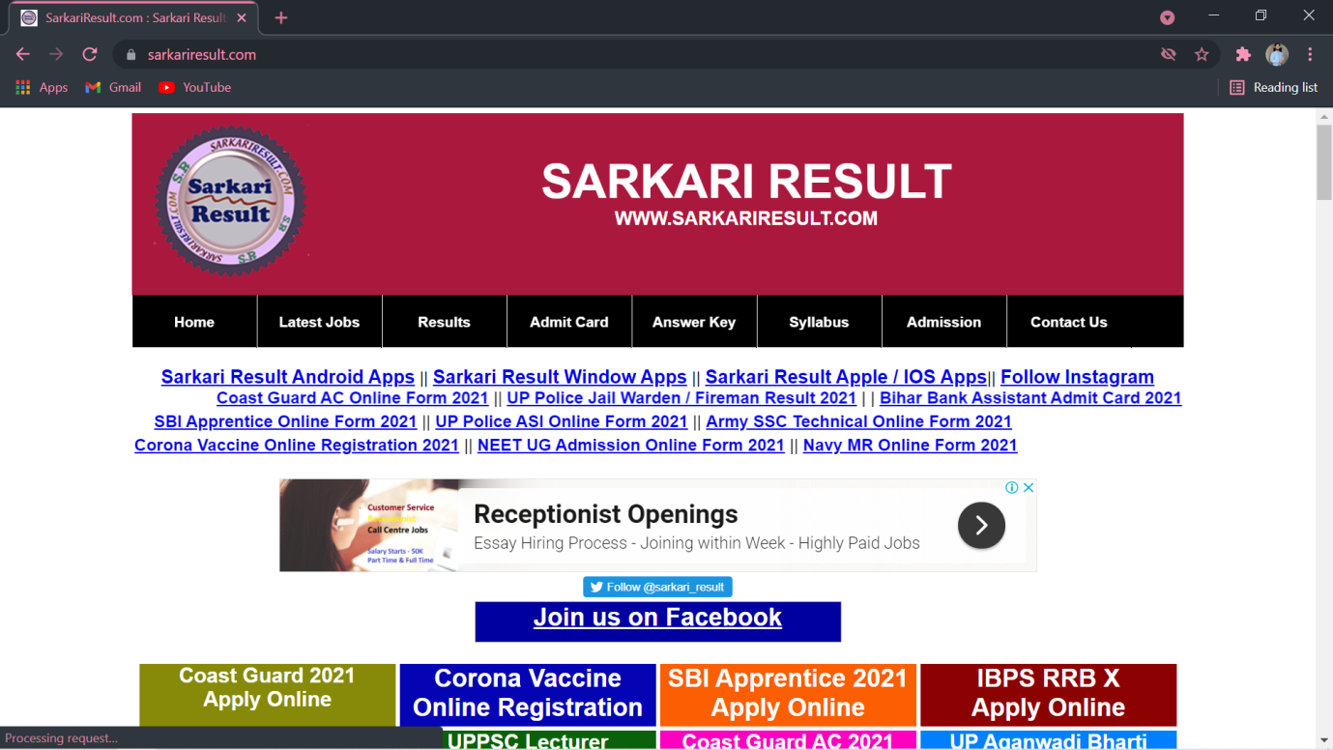

**Top Careers**

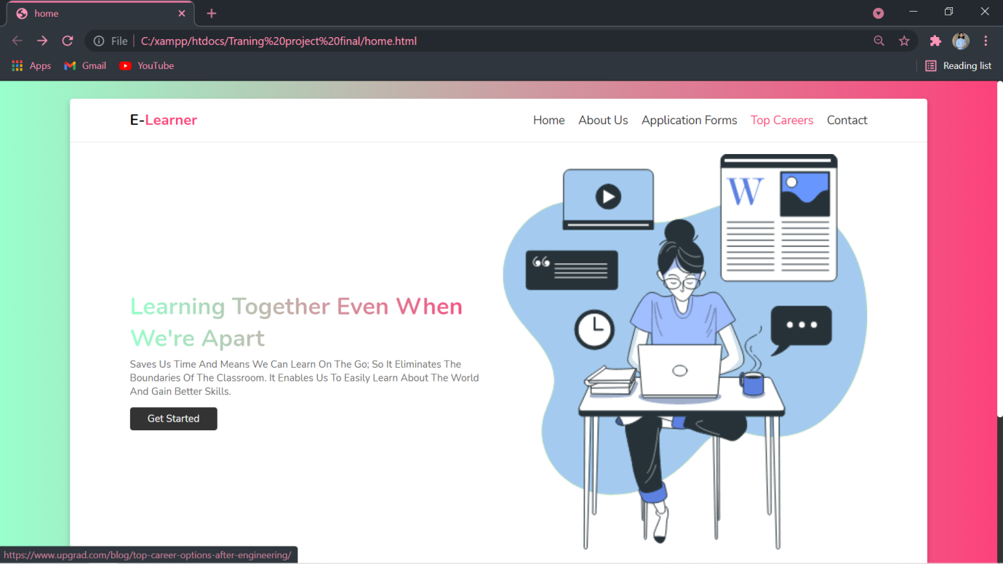

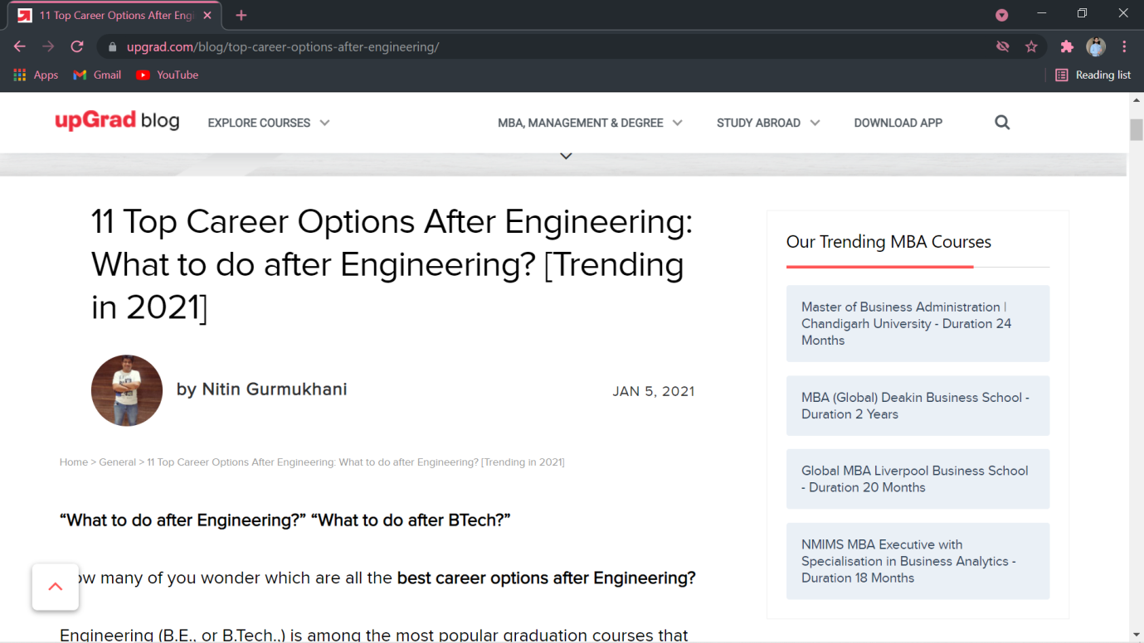

**CONTACT-**

<!DOCTYPE html>

<html>

<head>

<style>

.card {

  box-shadow: 0 4px 8px 0 rgba(0, 0, 0, 0.2);

  max-width: 300px;

  margin-left: 230px;

  text-align: center;

  font-family: arial;

}

.title {

  color: grey;

  font-size: 18px;

}

button {

  border: none;

  outline: 0;

  display: inline-block;

  padding: 8px;

  color: white;

  background-color: #000;

  text-align: center;

  cursor: pointer;

  width: 100%;

  font-size: 18px;

}

a {

  text-decoration: none;

  font-size: 22px;

  color: black;

}

button:hover, a:hover {

  opacity: 0.7;

}

body {font-family: Arial, Helvetica, sans-serif;

background: linear-gradient(to right, #ffffff 0%, #33ccff 80%);}

* {box-sizing: border-box;

}

input[type=text], select, textarea {

  width: 100%;

  padding: 12px;

  border: 1px solid #ccc;

  border-radius: 4px;

  box-sizing: border-box;

  margin-top: 6px;

  margin-bottom: 16px;

  resize: vertical;

}

input[type=submit] {

  background-color: #4CAF50;

  color: white;

  padding: 12px 20px;

  border: none;

  border-radius: 4px;

  cursor: pointer;

}

input[type=submit]:hover {

  background-color: #45a049;

}

.container {

  border-radius: 5px;

  background-color: #f2f2f2;

  padding: 20px;

  margin-right:50px ;

  margin-left:50px ;

  size: 100%;

}

table,td{

  text-align:center;

}

</style>

</head>

<body>

<table>

  <tr>

    <td width="50%">

<div class="card" >

  <img src="https://encrypted-tbn0.gstatic.com/images?q=tbn:ANd9GcQUMZoP2s2HMUGZHiS1Tz0YGt7SjwhiQ8qaUA&usqp=CAU" style="width:100%">

  </div>

</td>

<td width="50%">

<div class="container">

  <h3>Contact Us Form:-</h3>

  <form action="contact_form.php" method="REQUEST">

    <label for="firstname" >First Name</label>

    <input type="text" id="firstname" name="firstname" placeholder="Your name.." required>

    <label for="lastname"s>Last Name</label>

    <input type="text" id="lastname" name="lastname" placeholder="Your last name.." required>

 <label for="mobno" >Mob No:-</label>

    <input type="text" id="mobno" name="mobno" placeholder="Your Mob no" required>

    <label for="country">Country</label>

    <select id="country" name="country">

      <option value="Select Country">Select Country</option>

         <option value="india">India</option>

      <option value="australia">Australia</option>

      <option value="canada">Canada</option>

      <option value="usa">USA</option>

    </select>

    <label for="subject">Subject</label>

    <textarea id="subjects" name="subjects" placeholder="Write something.." style="height:200px"></textarea>

    <button onclick="alert('Your Details Submitted Successfully!')"><input type="submit" name="save" value="submit"></button>

  </form>

</div>

</td>

</tr>

</table>

</body>

</html>

**CONTACT-PHP**

<?php

$conn = mysqli_connect("localhost:3307", "root", "", "Shubham");

    if($conn === false){

        die("ERROR: The connection could not be PROCESSED! "

            . mysqli_connect_error());

    }

    $firstname =  $_REQUEST['firstname'];

    $lastname = $_REQUEST['lastname'];

    $mobno = $_REQUEST['mobno'];

    $country = $_REQUEST['country'];

    $subjects = $_REQUEST['subjects'];

    $sql = "INSERT into contact values ('$firstname', '$lastname', '$mobno', '$country', '$subjects')";

      if(mysqli_query($conn, $sql)){

          echo "CONGRATS!! DETAILS SAVED.";

      }

      else{

          echo "AHH!! SOME ERROR OCCURED.";

      }

      mysqli_close($conn);

?>

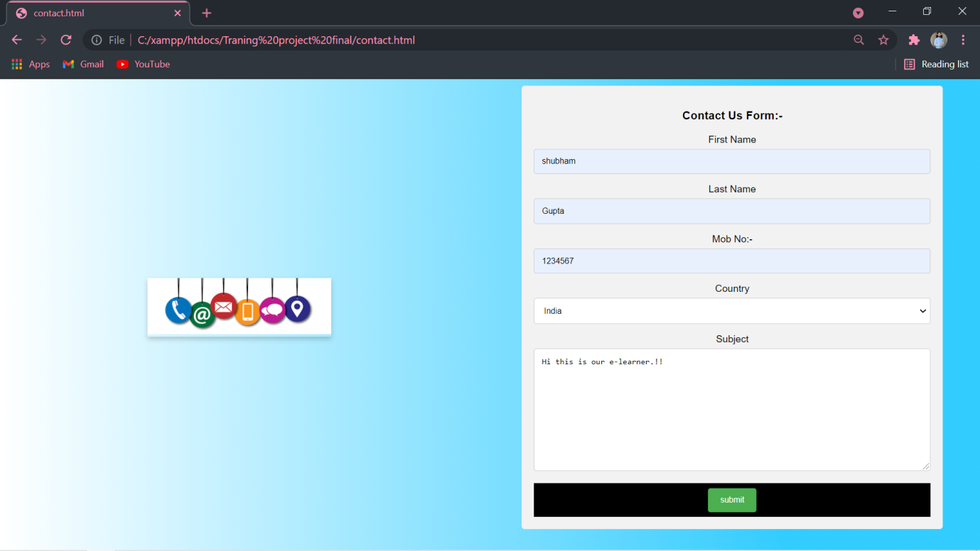

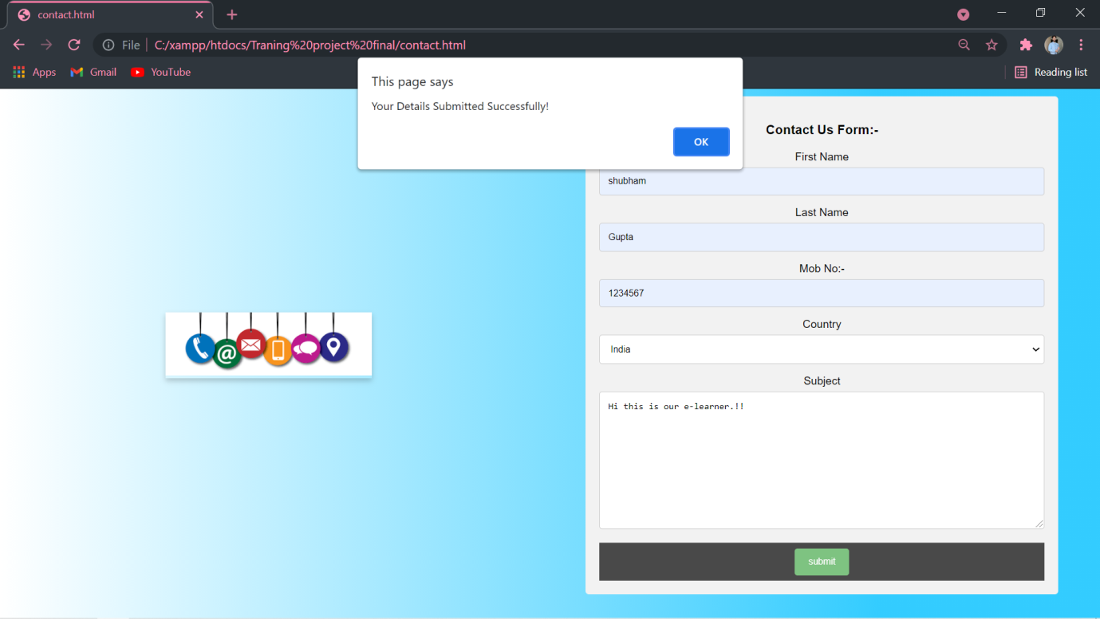

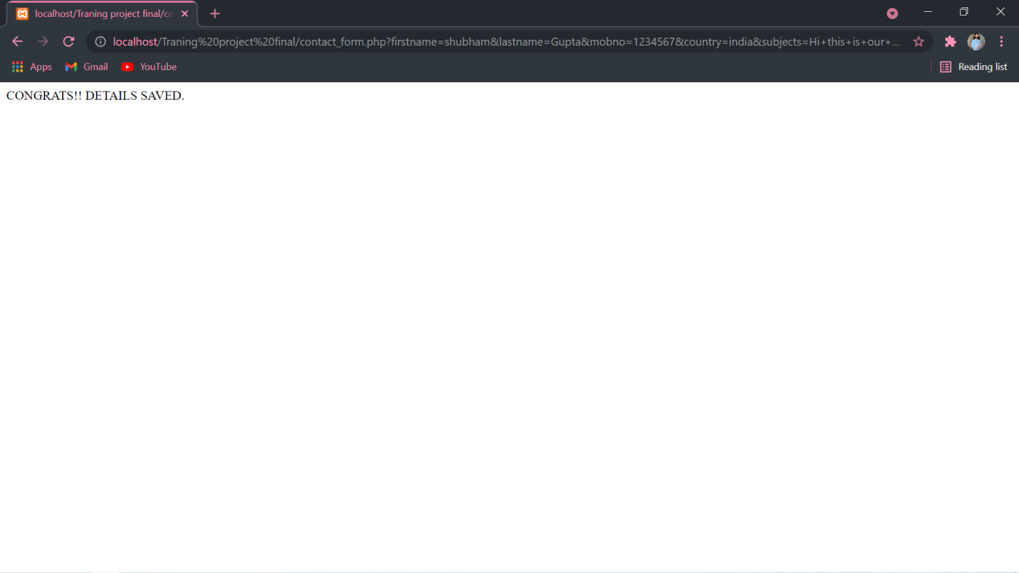

**LINKAGE WITH DBMS XAMPP**-

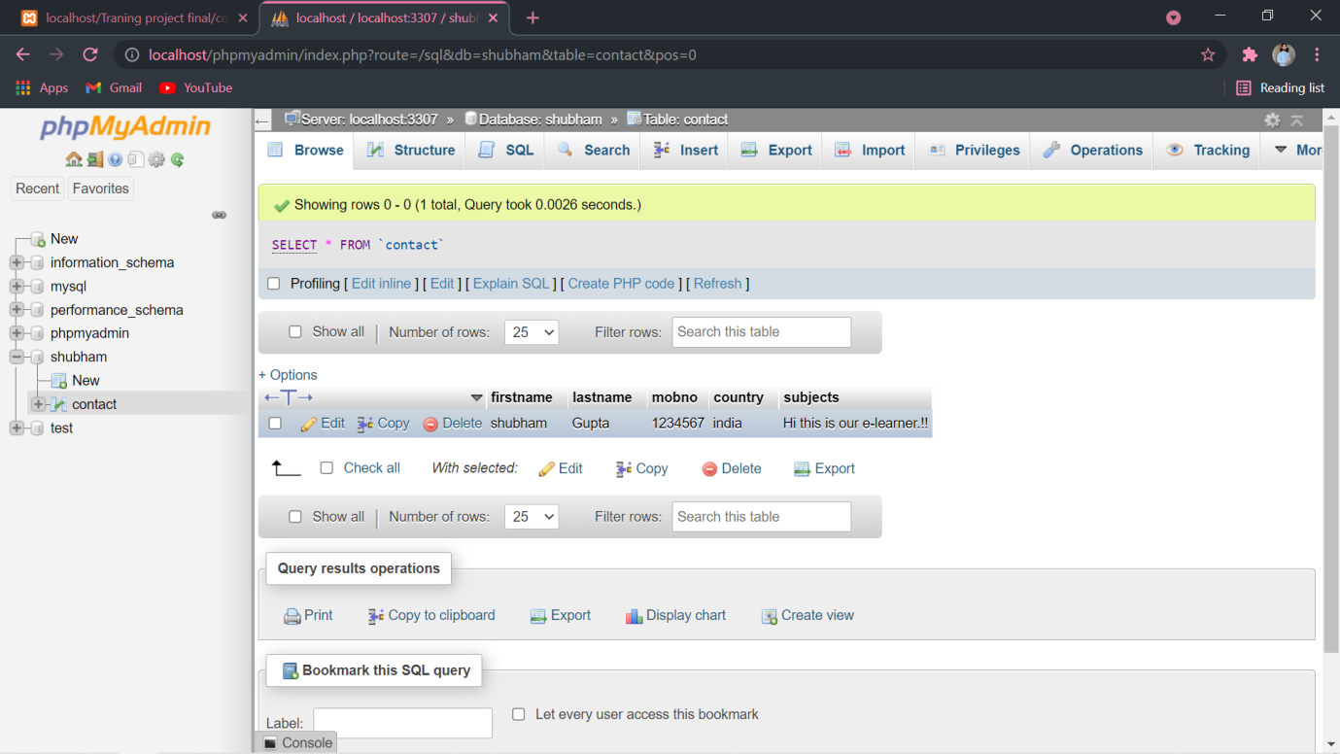

GET STARTED-

 <!DOCTYPE html>

 <html>

 <head>

    <title>Homepage/easynotes</title>

    <link rel="stylesheet" type="text/css" href="css/style1.css">

 </head>

<div style="background-image: url('images/1.jpg');">

 <body>

    <header>

        <div class="title">

            <h1>HAPPY STUDYING!</h1>

<br>

        </div>

        <div class="button">

            <a href="vidproject try.html"class="btn">WATCH VIDEO</a>

            <a href="notes.html"class="btn">TAKE NOTES</a>

<br> <br><br>

               <center> <a href="funzone.html"class="btn">fUn Zone</a></center>

        </div>

    </header>

 </body>

 </html>

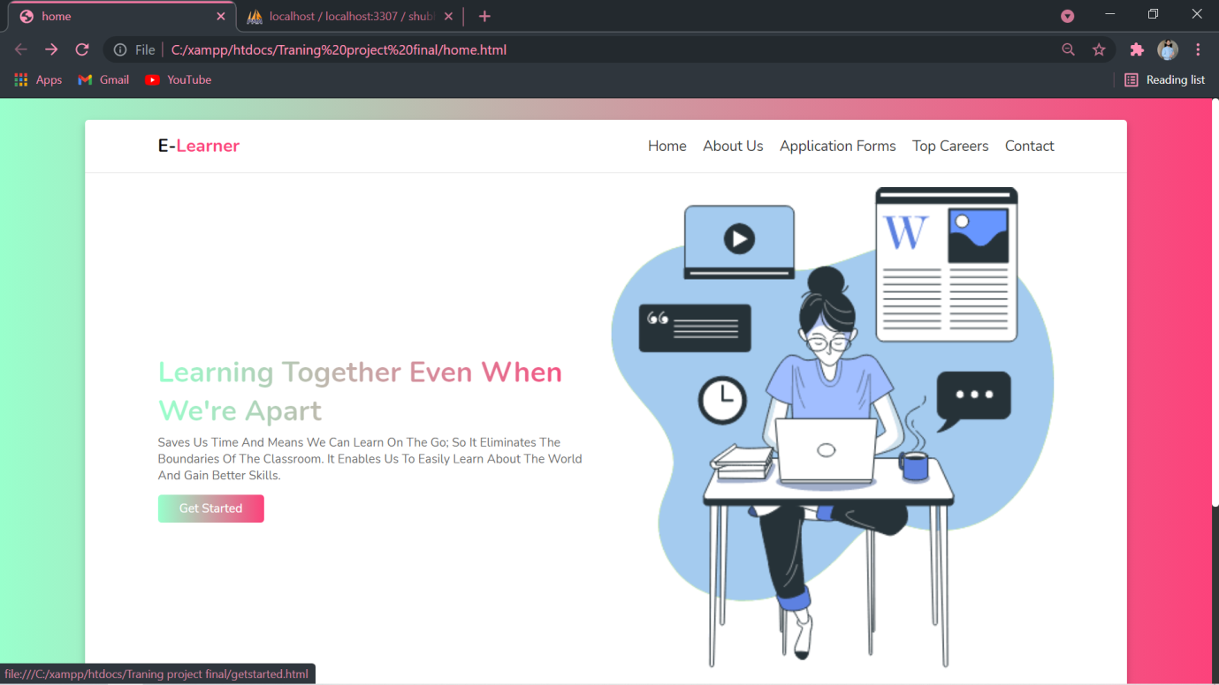

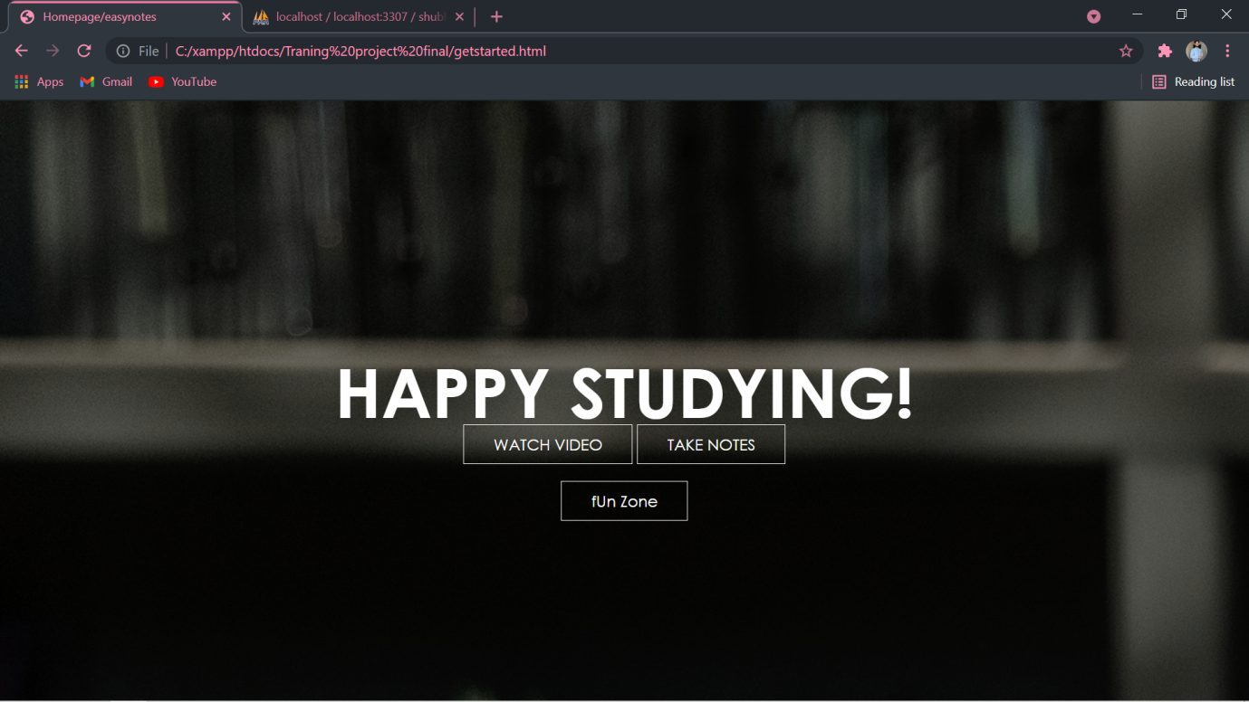

**WATCH VIDEO-**

<html>

<head>

    <title>video tutorials</title>

<style type="text/css">

    table,th{

        padding: 30px;

        border-spacing:100px;

        margin:auto;

            text-align: center;

    }

    a{

        text-decoration: none;

         border:3px solid black;

         padding: 15px 25px;

          background-color:#ccffeb;

          display: inline-block;

    }

    a:hover{

        background-color: #008080 ;

        transition: 0.6s ease;

        color:white;

        padding: 24px 34px;

        border:none;

    }

    body{

        background-image: url("vid1.jpg");

                background-repeat:no-repeat;

                background-size: cover;

    }

</style>

</head>

<body>

   <table>

    <caption style="font-size:40px; color:#ffffff"><br>

        SELECT SUBJECT

    </caption>

    <tr>

        <th>

            <a href="https://youtu.be/FjaJEo7knF4"target="_blank">BEEE</a>

        </th>

        <th>

            <a href="https://www.youtube.com/watch?v=cCP_IZa0yWc&list=PL-eLHEko-mgJmL0lizj9NelH38vYfiJfi"target="_blank">PHYSICS</a>

        </th>

        <th>

            <a href="https://www.youtube.com/watch?v=nFUU2n6o7SM&list=PLVCBPCYGv7bA8ck9TIDlrvfJNOKtFkx-5"target="_blank">MATHS</a>

        </th>

    </tr>

    <tr>

        <th>

            <a href="https://youtu.be/7Dh73z3icd8"target="_blank">C LANGUAGE</a>

        </th>

        <th>

            <a href="https://youtu.be/z9bZufPHFLU"target="_blank">C++ LANGUAGE</a>

        </th>

        <th>

            <a href="https://www.youtube.com/watch?v=gQojMIhELvM&list=PLoYCgNOIyGAB_8_iq1cL8MVeun7cB6eNc"target="_blank">WEB DEVELOPMENT</a>

        </th>

    </tr>

    <tr>

       <th>

         <a href="https://www.youtube.com/watch?v=r59xYe3Vyks&list=PLS1QulWo1RIbfTjQvTdj8Y6yyq4R7g-Al"target="_blank"> JAVA</a>

       </th>

       <th>

         <a href="https://www.youtube.com/watch?v=SXmVym6L8dw&list=PLAC325451207E3105"target="_blank"> C#(SHARP)</a>

       </th>

       <th>

         <a href="https://www.youtube.com/watch?v=QXeEoD0pB3E&list=PLsyeobzWxl7poL9JTVyndKe62ieoN-MZ3"target="_blank">PYTHON</a>

       </th>

   </tr>

   </table>

</body>

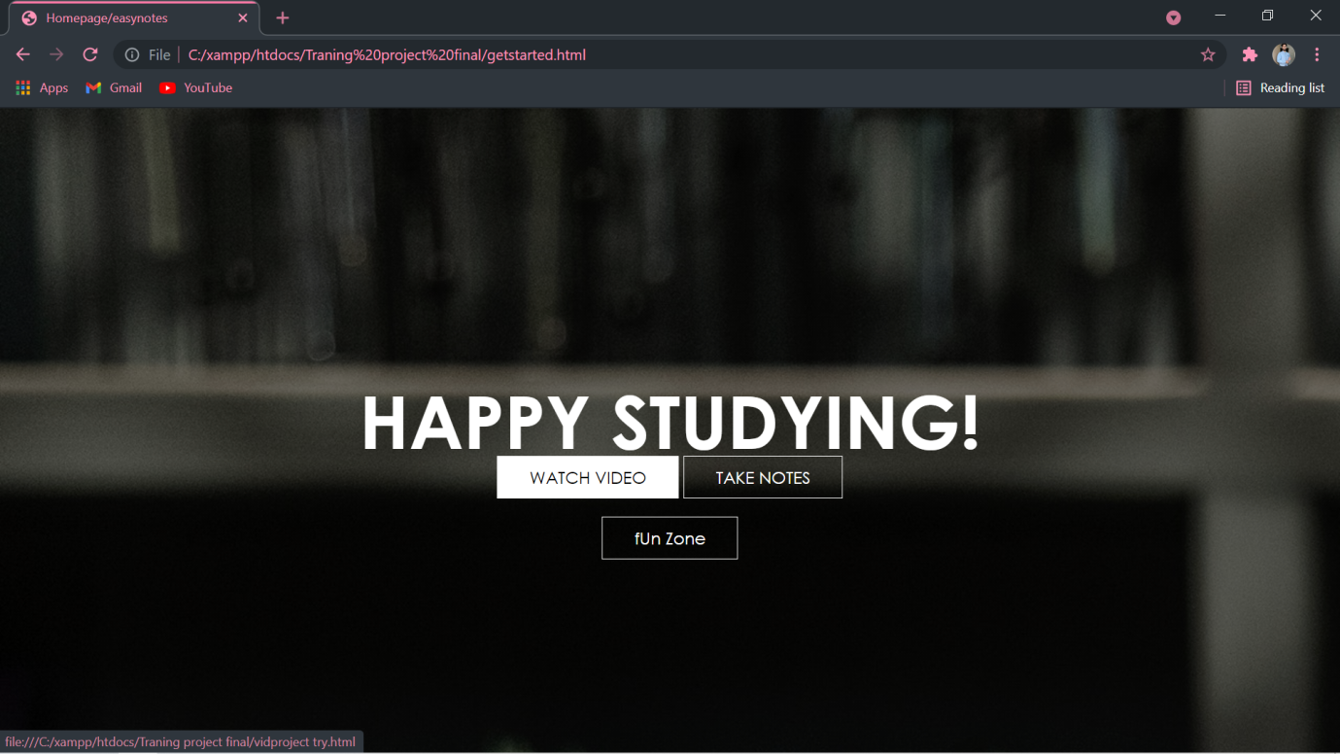

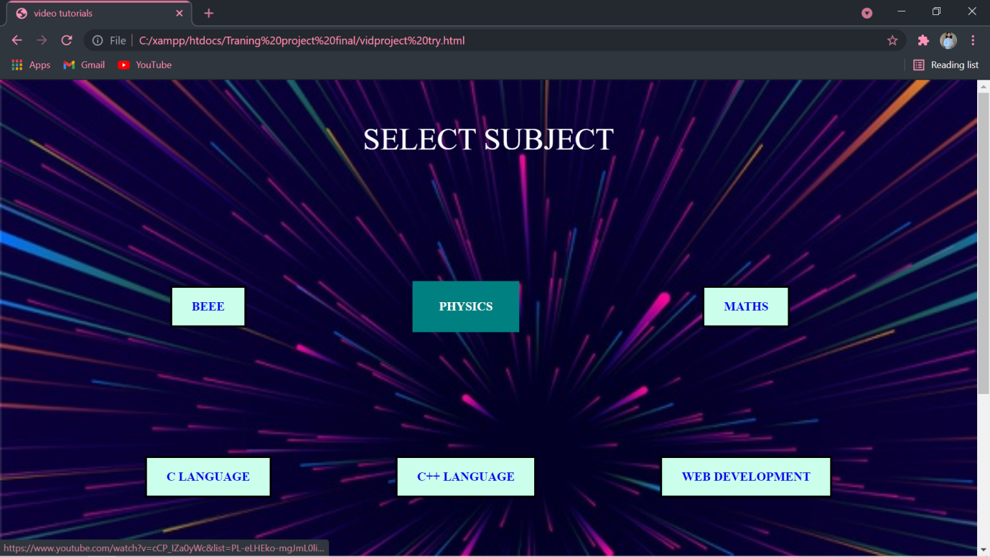

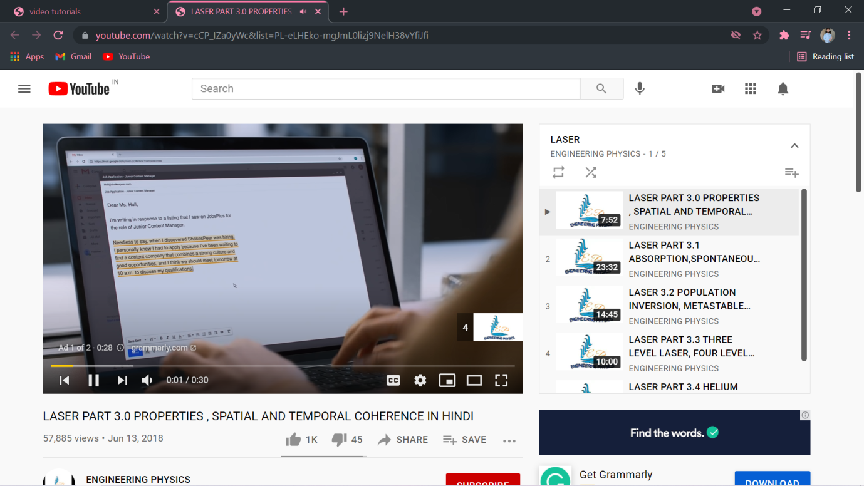

**NOTES-**

<!DOCTYPE html>

<html>

<head>

<style>

.title {

     margin-top: 0px;

    font-family: 'Open Sans', sans-serif;

    font-size: 30px;

    text-align: center;

    color: #2E3D49;

}

.cbox {

    position: relative;

    width: 100%;

    display: inline-flex;

    flex-wrap: wrap;

    justify-content: center;

}

.cbox .det {

    width: 250px;

    height: 80px;

    margin: 10px;

    cursor: pointer;

}

.cbox .det a{

    justify-content: space-around;

    width: 250px;

    padding: 28px;

    border-radius: 10px;

    border: 3px solid #FA4B37;

    font-size: 15px;

    color: #272529;

    font-family: cursive;

    text-decoration: none;

}

.cbox .det a:hover {

    background: linear-gradient(to right, #FA4B37, #DF2771);

    color: white;

}

.cbox .det a:hover img{

    filter: brightness(100);

}

.cbox img {

    width: 20px;

    margin-right: 20px;

}

</style>

</head>

<body background="post1.jpg">

<br>

<br>

*<!-- Some Popular Subjects -->*

    <div class="title">

        <span>Popular Subjects</span>

    </div>

    <br><br>

    <div class="course">

        <center><div class="cbox">

        <div class="det"><a href="c++.html">C++</a></div>

        <div class="det"><a href="de.html">DE</a></div>

        <div class="det"><a href="bio.html">Biology</a></div>

        <div class="det"><a href="beee.html">BEEE</a></div>

</div></center>

<br> <br>

                <div class="title">

                 <span>Competative ZoNe</span></div><br> <br>

        <div class="cbox">

        <div class="det"><a href="amcat.html">AMCAT</a></div>

        <div class="det"><a href="https://www.askiitians.com/free-lessons-for-iit-jee.aspx">JEE-mains</a></div>

        <div class="det"><a href="https://www.prep.youth4work.com/defence/nda-test">NDA</a></div>

        <div class="det"><a href="https://www.wiziq.com/tutorials/neet">NEET</a></div>

        </div>

    </div>

</body>

</html>

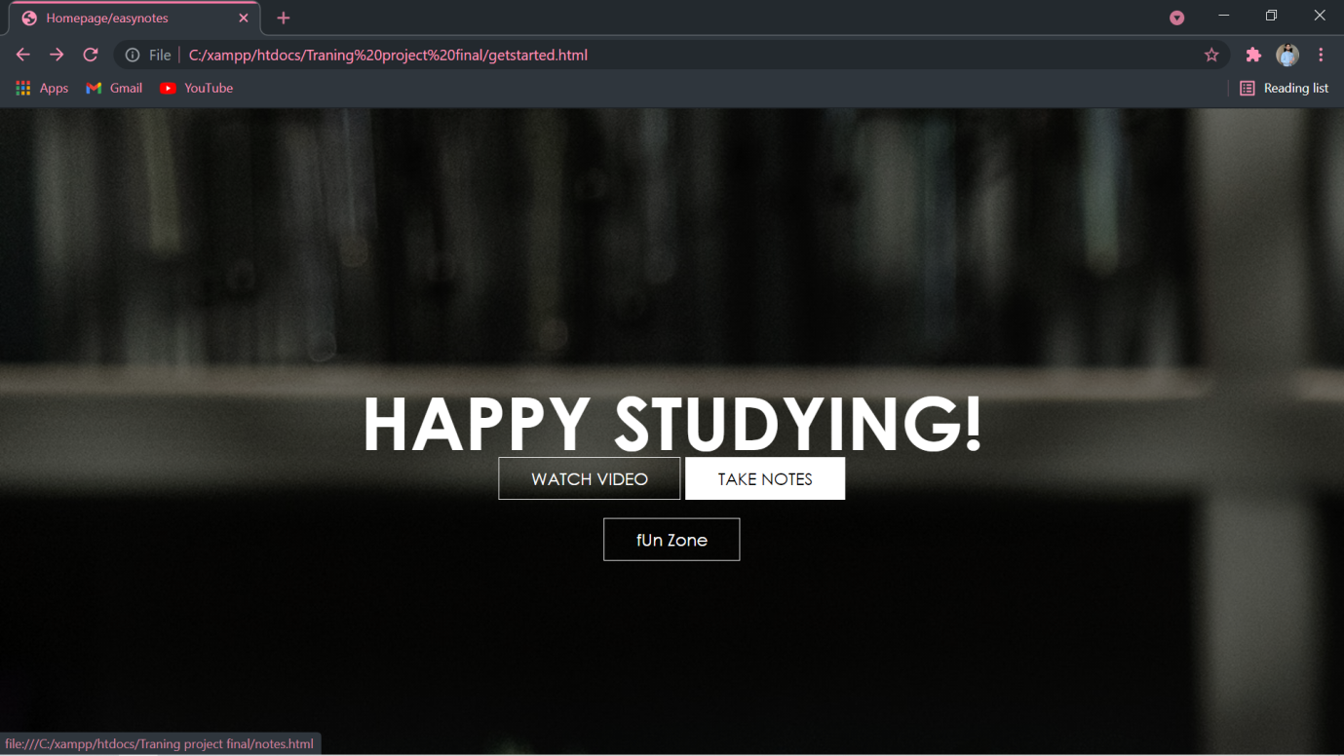

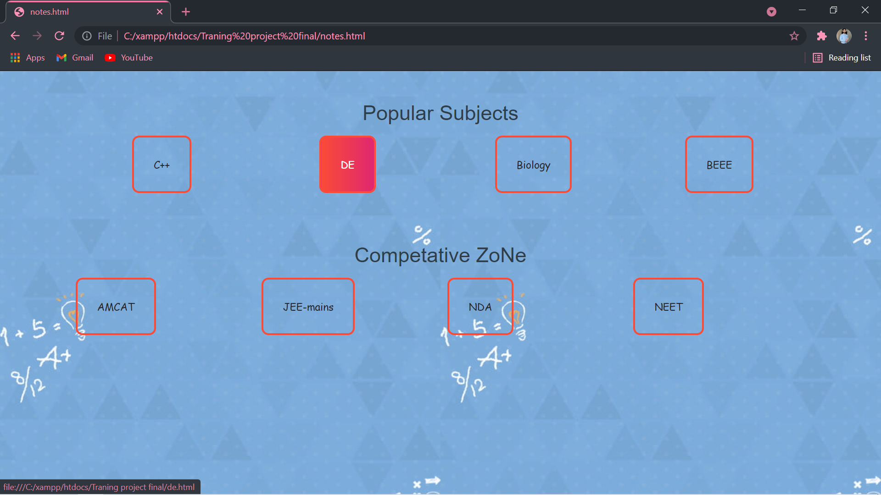

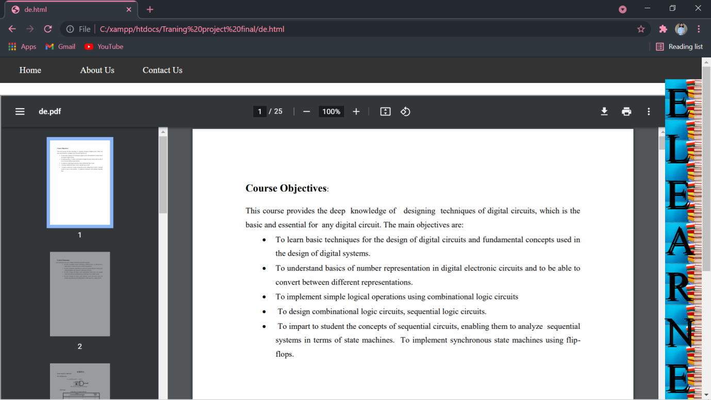

**FUNZONE-**

<!DOCTYPE html>

<html>

<head>

<style>

body {

  background-image: url('https://encrypted-tbn0.gstatic.com/images?q=tbn:ANd9GcQIwNOsEXbKjSMKRBgE8Vh9KyOcIrkwDW2smQ&usqp=CAU');

  background-repeat: no-repeat;

  background-attachment: fixed;

  background-size: cover;

}

.title {

     margin-top: 0px;

    font-family: 'Open Sans', sans-serif;

    font-size: 30px;

    text-align: center;

    color: #063970;

}

.cbox {

    position: relative;

    width: 100%;

    display: inline-flex;

    flex-wrap: wrap;

    justify-content: center;

}

.cbox .det {

    width: 250px;

    height: 80px;

    margin: 10px;

    cursor: pointer;

}

.cbox .det a{

    justify-content: space-around;

    width: 250px;

    padding: 28px;

    border-radius: 10px;

    border: 3px solid black;

    font-size: 15px;

    color: #272529;

    font-family: cursive;

    text-decoration: none;

        background: linear-gradient(to right, #DF2771, #9999ff);

}

.cbox .det a:hover {

    background: linear-gradient(to right, #DF2771, #ccfff5);

    color: white;

}

.cbox .det a:hover img{

    filter: brightness(100);

}

.cbox img {

    width: 20px;

    margin-right: 20px;

}

</style>

</head>

<body>

<br>

<br>

<br> <br>

                <div class="title">

                <h2> <span>fUn ZoNe</span></div><br></h2>

        <div class="cbox">

        <div class="det"><a href="https://www.google.com/logos/2010/pacman10-i.html"><b>PAC MAN</b></a><br><br><br><br><br>

        <div class="det"><a href="https://www.google.com/search?q=play%20snake"><b>SNAKE</b></a><br><br><br><Br><Br>

        <div class="det"><a href="https://www.google.com/search?q=play%20tic%20tac%20toe"><b>TIC-TAC-TOE</b></a><br><br><br><br><br><br>

        <div class="det"><a href="https://flappybird.io/"><b>Flappy-Bird</b></a>

        </div>

    </div>

</body>

</html>

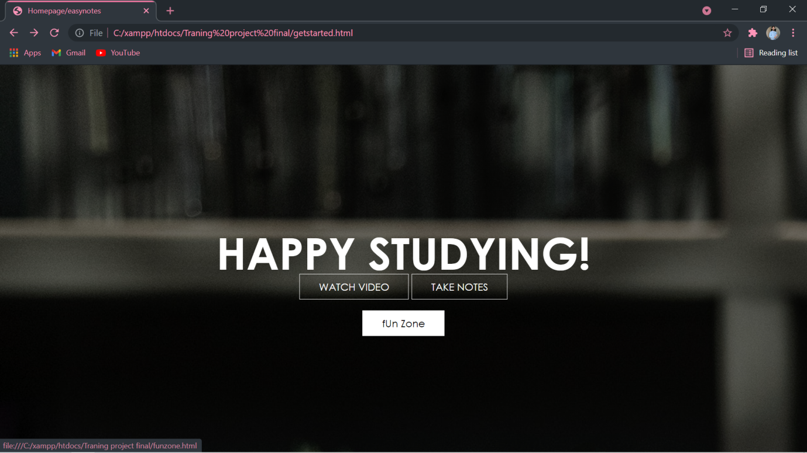

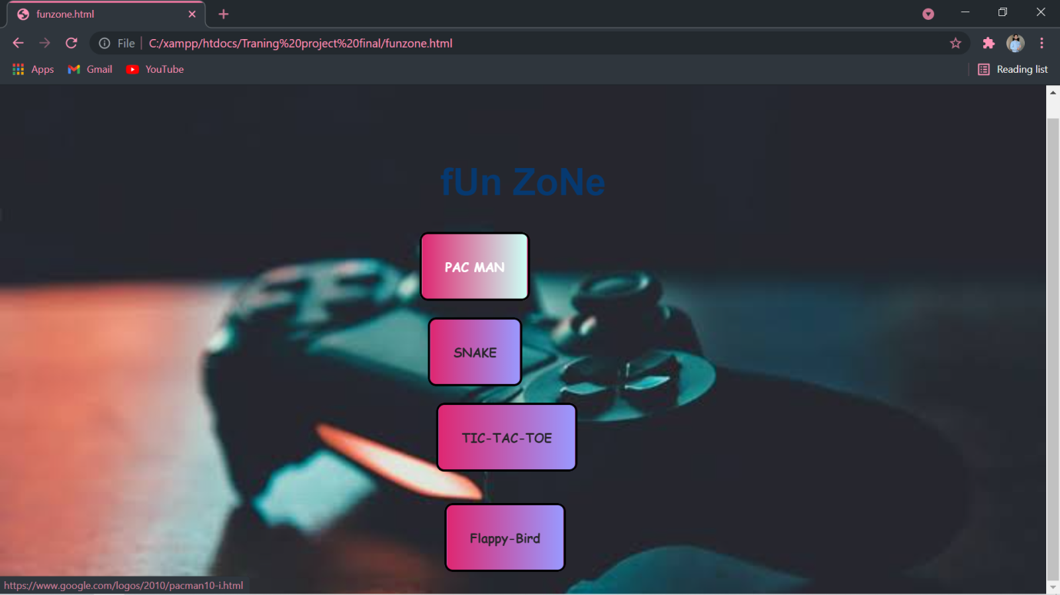

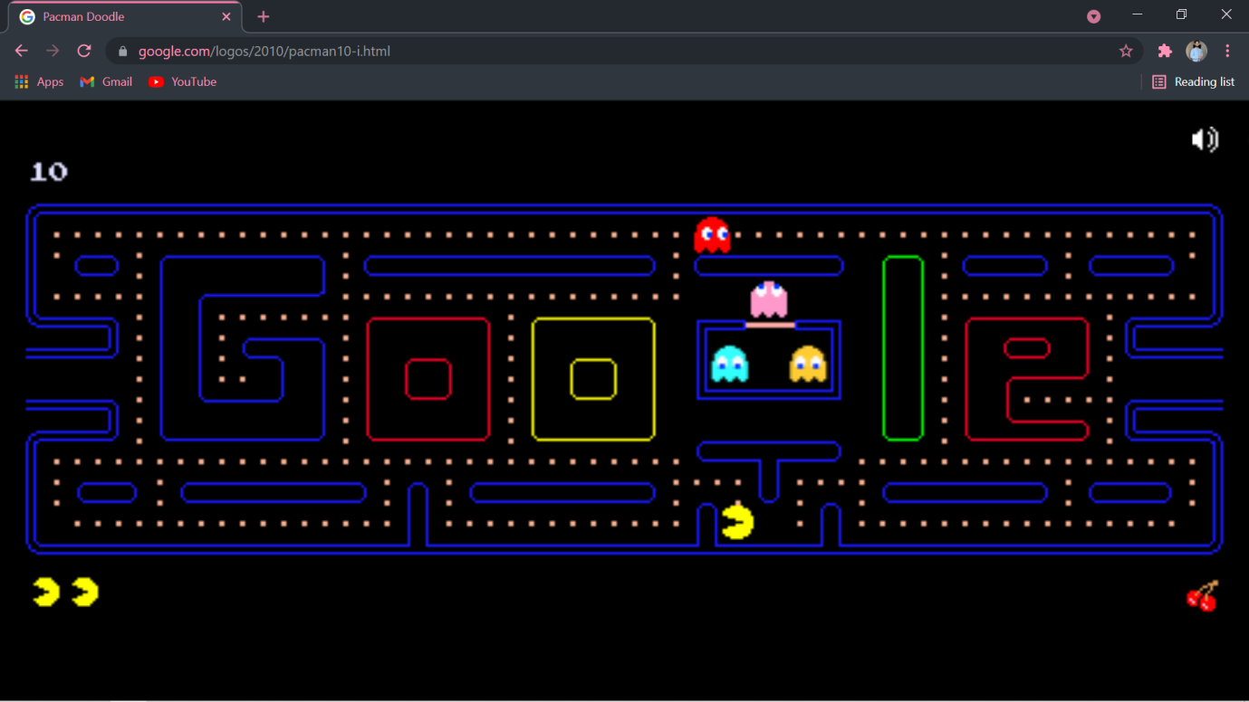

**FOLLOW US LINK-**

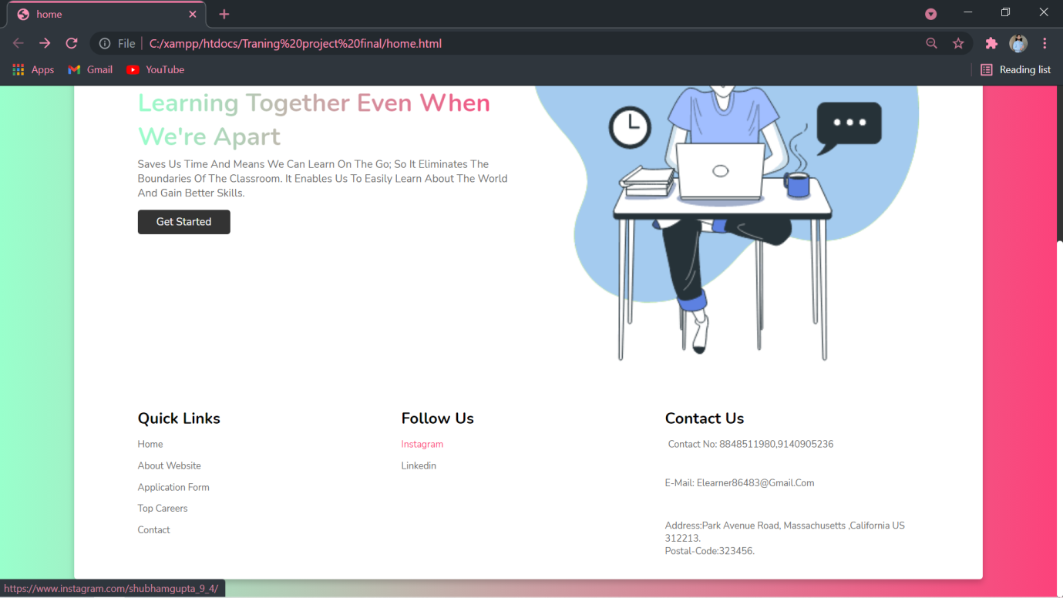

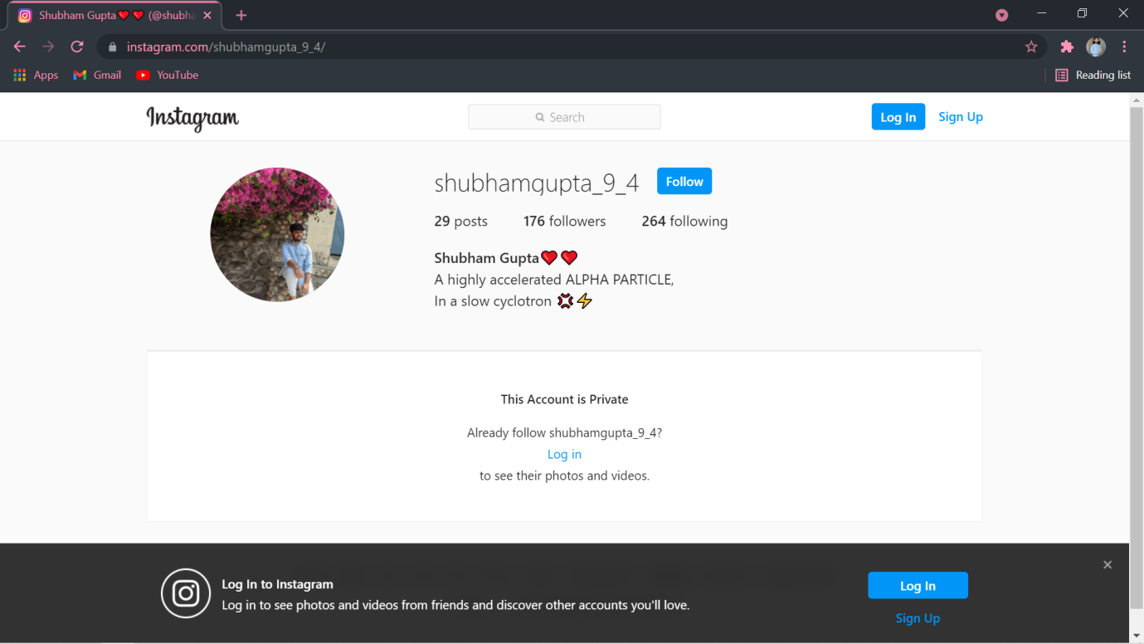

**CHAPTER 4**

**CONCLUSION AND FUTURE SCOPE**

Our project has been prepared by looking at present situation where education has become distanced learning. Several user-friendly coding has also been adopted. The objective of the project is to provide an attractive way of learning and a user-friendly environment.

### POSSIBLE FUTURE WORK

* + - We can give more advance software for E-Learning and add more facilities.
    - We can add brain boosting activities.
    - Integrate multiple load balancers to distribute the load of system.
    - Create a backup mechanism for backing up data and information.
    - We will host the platform on online servers, to make it accessible worldwide.
    - Today, the market place is flooded with several E-learning websites so that the student could choose according to his requirements and understanding.
    - Today, it is a reality in India. In the last couple of years, the growth of education has been phenomenal as more educators have started teaching in their own ways providing their own materials.
    - There is enough scope for E-Learning in the future if we understand the students psyche and cater to their needs.

**REFERENCES**

* W3SCHOOL- W3Schools is a school for web developers, covering all the aspects of web development. W3Schools was created in 1998, and derives its name from the World Wide Web (WWW) but is not affiliated with the W3C. W3Schools has focus on simplicity.

W3Schools practice easy learning.

W3Schools uses simple code examples and simple illustrations of how to use it.

W3Schools' tutorials start from basic level and move all the way up to professional references.

**YOUTUBE-** YouTube has been a great source for students for clearing their doubts in any of fields.

**Ppt’s provided by the teacher-** A lot of help was taken from the ppts that was provided by the teacher.